1. **PriorityBlockingQueue**:
   1. Orders the elements in natural sorting order or we should define Comparator.
2. 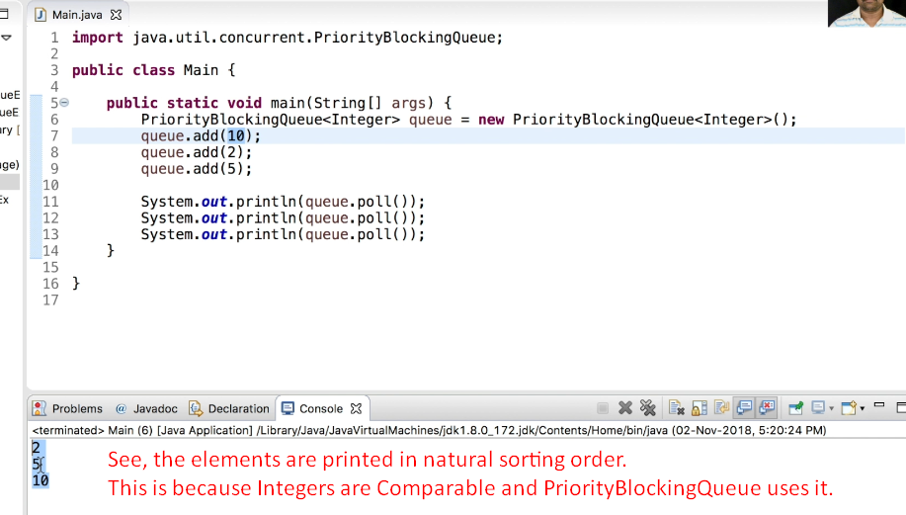
3. 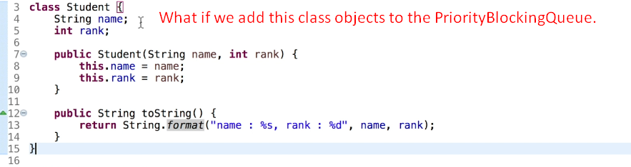
4. 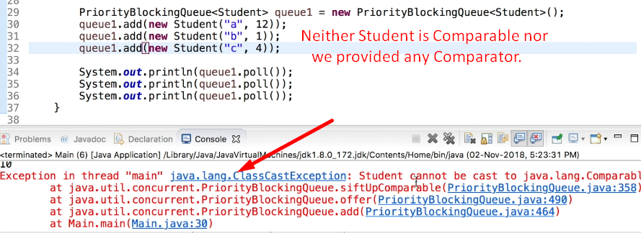
5. 